FIGMA

1

**CHAPTER 2**

**How to start this session?**

✓Import file to **Figma**

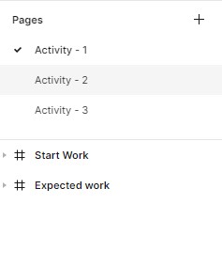

✓The file contains **3 pages**

✓Each page has **start work** and **expected work**

How to **work fast** on FIGMA ?

* 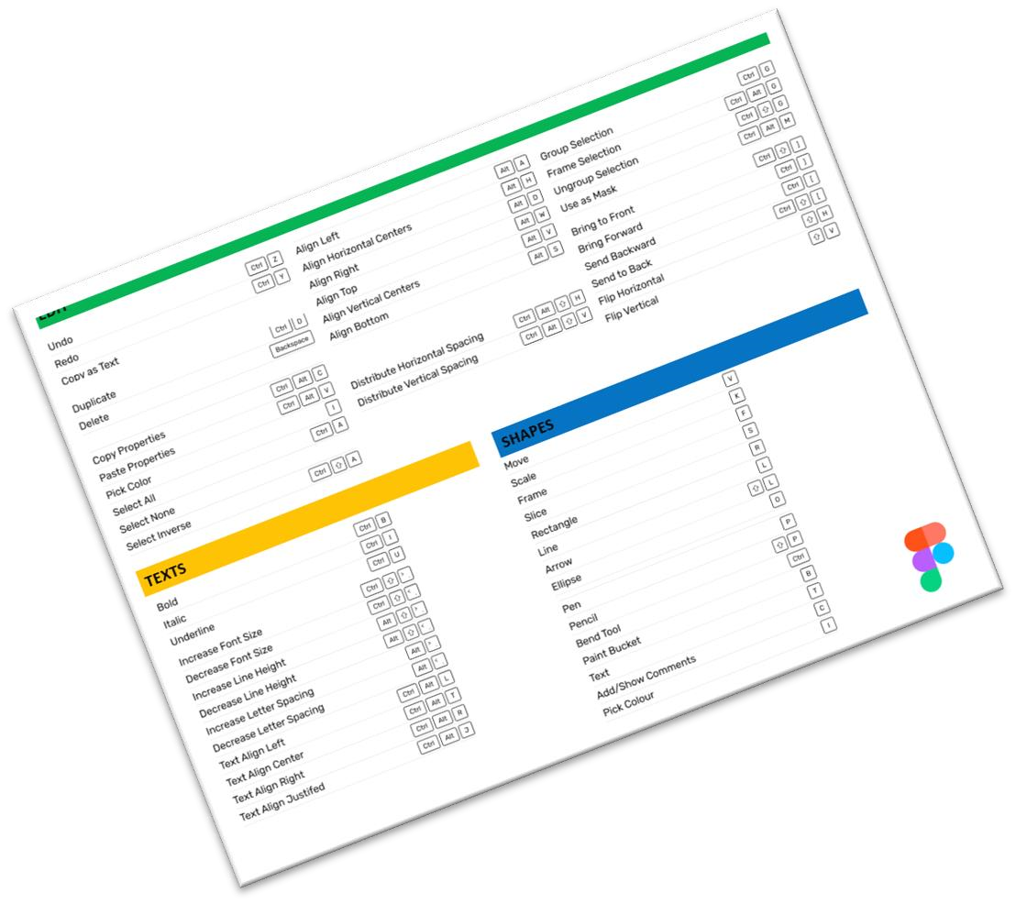use the **MOUSE** as much as possible
* use **SHORTCUTS** as much as possible

*Read the HANDOUT to learn the shortcuts*

Activity 1

20 MIN INDIV

* Use **alignment properties** only
* Analyze which **elements** you should start with

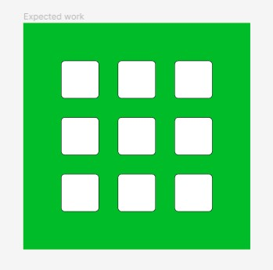

**50**

**100**

**400**

* Change the **color** by use **color dropper**
* Use **Copy** | **Paste properties** to **copy** the **style** from one **square** to **another**

# Activity 2



20 MIN INDIV Step 1

Design the card as follows

Frame size 950 x 550

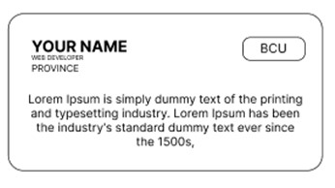

**200**

**400**

**20**

**8**

**12**

**80**

**x**

**30**

**30**

**25**

**25**

# Activity 2

20 MIN INDIV Step 2

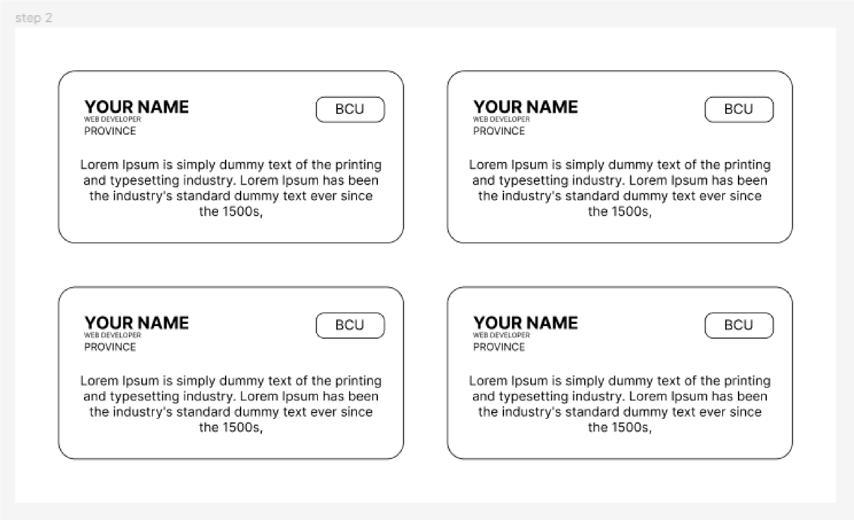

**50**

**50**

**50**

**50**

Duplicate the card as follows

Step 1

|  |  |
| --- | --- |
| 20 MIN | INDIV |

* **Frame type** is **iPhone 14 pro**



**cover**

**profile**

**content**

* **Cover height** is **250**
* **Content height** is **590**
* **Profile size** is **260 x 260**
* **Frame background color** is **000000**
* **Cover background color** is **EEEEEE**
* **Content background color** is **FFFFFF**
* **Profile background color** is **D9D9D9**

20 MIN INDIV Step 2

* **Name size** is **260 x 50**

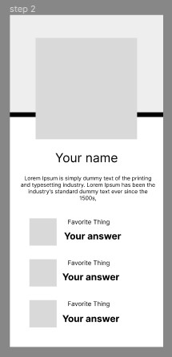

**Name**

**B**

**io**

**Tile**

**Answe**

**r**

**20**

**40**

**50**

**10**

**25**

* **Bio size** is **350 x 70**
* **Title size** is **145 x 20** ✓ **Image size** is **70 x 70**
* **Answer size** is **155 x 20**

**Image**

Step 3

20 MIN INDIV

✓ **Change the content**

